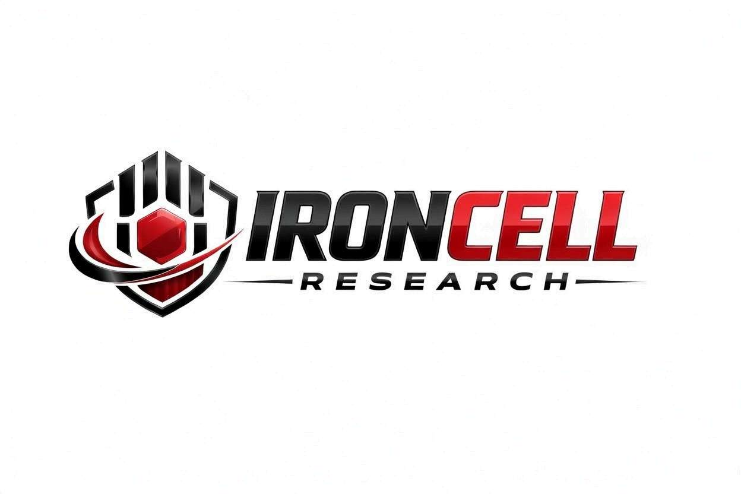
PEPTIDE RESEARCH BRIEF
CJC-1295 / Ipamorelin
GHRH + GHRP Synergistic Blend | Growth Hormone Optimization Stack

Description, Benefits, Dosage & Research Overview

Iron Cell Research
IronCellResearch.com
For Research Use Only


Compound Overview
Blend Components | CJC-1295 without DAC (Mod GRF 1-29) + Ipamorelin
Classification | GHRH Analog + Selective Growth Hormone-Releasing Peptide (GHRP)
CJC-1295 (no DAC) | Modified GRF(1-29), 29 amino acids, MW 3367.9 g/mol
Ipamorelin | Pentapeptide ghrelin mimetic, 5 amino acids, MW 711.85 g/mol
CAS Numbers | CJC-1295: 863288-34-0 | Ipamorelin: 170851-70-4
Combined Half-Life | CJC-1295: ~30 min | Ipamorelin: ~2 hours
Purity | Greater than or equal to 99% (each component)
Storage | Lyophilized, -20C, protected from light and moisture
Research Status | Extensively studied combination; considered gold-standard GH secretagogue stack

Description
The CJC-1295 (no DAC) / Ipamorelin combination is widely regarded as the gold-standard growth hormone secretagogue stack. This blend pairs two complementary peptides that act through entirely different receptor pathways to produce synergistic GH release far exceeding what either peptide achieves alone.
CJC-1295 without DAC (Modified GRF 1-29) is a synthetic GHRH analog that stimulates the GHRH receptor on pituitary somatotrophs, amplifying the magnitude of each GH pulse. Ipamorelin is a highly selective pentapeptide ghrelin mimetic that activates the growth hormone secretagogue receptor (GHS-R1a), increasing the number of somatotrophs that fire and simultaneously suppressing somatostatin, the natural inhibitor of GH release.
What makes this combination particularly attractive is Ipamorelin's exceptional selectivity. Unlike older GHRPs such as GHRP-6 and GHRP-2, Ipamorelin does not significantly elevate cortisol, prolactin, or aldosterone at standard doses. Combined with the physiological pulsatile release pattern of CJC-1295 (no DAC), this stack produces robust GH elevation with a remarkably clean side-effect profile.

Mechanism of Action

Dual-Pathway GH Stimulation
CJC-1295 and Ipamorelin stimulate GH release through two independent and synergistic receptor systems. CJC-1295 activates the GHRH receptor (GHRHR), increasing cAMP and amplifying the amplitude of each GH pulse. Ipamorelin activates the GHS-R1a (ghrelin receptor), which signals through a Gq/phospholipase C/IP3 pathway to increase intracellular calcium and recruit additional somatotrophs. The combined effect produces GH output 3-5 times greater than either peptide alone.

Somatostatin Suppression
Ipamorelin functionally suppresses somatostatin (SST) release from the hypothalamus, removing the primary brake on GH secretion. This allows CJC-1295's GHRH signal to reach the pituitary unopposed, dramatically increasing the GH response. This dual mechanism of amplifying the accelerator (GHRH) while releasing the brake (SST suppression) is the foundation of the synergistic effect.

Pulsatile Physiological Release
The short half-lives of both components (CJC-1295: ~30 min, Ipamorelin: ~2 hours) produce a sharp, defined GH pulse lasting approximately 2-3 hours. This closely mimics the body's natural GH secretion pattern, preserving negative feedback loops and preventing receptor desensitization. The result is sustainable, long-term GH optimization without tachyphylaxis.

Selective Hormone Profile
Ipamorelin's selectivity for the GHS-R1a receptor means it does not activate receptors that stimulate cortisol (ACTH), prolactin, or aldosterone release. This clean selectivity, combined with CJC-1295's specific GHRHR activation, produces a GH-dominant hormonal response without the unwanted side effects of older secretagogue combinations.

Research Benefits

Growth Hormone Optimization
- Synergistic GH Release: Combined administration produces 3-5x greater GH output than either peptide alone, with peak GH levels comparable to young-adult nocturnal pulses.
- IGF-1 Normalization: Restores IGF-1 levels to the upper physiological range, supporting systemic anabolic and regenerative signaling.
- Pulsatility Preservation: Maintains natural GH pulse frequency and amplitude patterns, unlike continuous exogenous GH administration.
- Long-Term Sustainability: Pulsatile release pattern prevents receptor desensitization, allowing sustained efficacy over extended research protocols.

Body Composition
- Visceral Fat Reduction: GH-mediated lipolysis preferentially targets visceral adipose tissue, reducing metabolically dangerous abdominal fat.
- Lean Mass Accretion: IGF-1 elevation drives muscle protein synthesis, nitrogen retention, and satellite cell activation.
- Body Recomposition: Simultaneous fat loss and lean tissue gain, particularly effective when combined with resistance training.
- Metabolic Rate: Increased resting energy expenditure through enhanced lean mass and direct GH effects on thermogenesis.

Recovery & Performance
- Muscle Recovery: Accelerates post-exercise recovery through enhanced protein synthesis and reduced inflammatory markers.
- Connective Tissue: IGF-1-mediated collagen synthesis strengthens tendons, ligaments, and joint cartilage.
- Injury Rehabilitation: Promotes tissue repair cascades including angiogenesis, fibroblast proliferation, and extracellular matrix remodeling.
- Exercise Capacity: Improved recovery allows higher training volume and frequency.

Sleep Quality
- Deep Sleep Enhancement: Pre-bed dosing enhances slow-wave (Stage 3/4) sleep, during which the majority of endogenous GH is naturally released.
- Sleep Architecture: Improved sleep quality and duration reported in research subjects.
- Overnight Recovery: Enhanced nocturnal GH release maximizes tissue repair and metabolic restoration during sleep.

Anti-Aging & Longevity
- Somatopause Reversal: Restores age-related decline in GH/IGF-1 axis to youthful physiological levels.
- Skin & Hair Quality: GH and IGF-1 stimulate collagen production, improving skin thickness, elasticity, hydration, and hair growth.
- Cognitive Support: IGF-1 promotes neurogenesis, synaptic plasticity, and neuroprotective signaling.
- Bone Density: Stimulates osteoblast activity and bone mineral density through IGF-1-mediated pathways.

Immune Function
- Thymic Regeneration: GH has been shown to promote thymic tissue regeneration, supporting T-cell maturation and immune competence.
- Immune Cell Activity: Enhanced NK cell activity and improved lymphocyte function through GH/IGF-1 signaling.

Dosage & Administration
The following dosage information is provided for research reference purposes only. Both peptides are typically administered together in the same injection.
Protocol | Dose Range | Route | Frequency
Low / Introductory | 100 mcg CJC + 100 mcg Ipam | SubQ Injection | 1x daily (pre-bed)
Standard | 100 mcg CJC + 200 mcg Ipam | SubQ Injection | 1-2x daily
Optimized | 150 mcg CJC + 200 mcg Ipam | SubQ Injection | 2-3x daily (AM, post-workout, pre-bed)
Advanced | 150 mcg CJC + 300 mcg Ipam | SubQ Injection | 2-3x daily

Optimal Timing Protocol
Pre-Bed (Primary) | Most important dose; amplifies natural nocturnal GH surge during deep sleep
Morning (Fasted) | Upon waking, before eating; aligns with natural AM cortisol trough
Post-Workout | 30-60 minutes after training; leverages exercise-induced GH priming
Fasting Requirement | Administer on empty stomach (2+ hours fasted); avoid food 30 min post-injection
Why Fasting Matters | Insulin and blood glucose blunt GH release; fats/carbs are most suppressive

Reconstitution Guidelines
Solvent | Sterile bacteriostatic water
Reconstitution | 1-2 mL BAC water per vial; can be drawn from separate vials into same syringe
Pre-Mixed Vials | If supplied as blend, reconstitute per manufacturer instructions
Mixing | Gently swirl until dissolved, never shake
Storage | Refrigerate at 2-8C, use within 21 days once reconstituted
Injection Site | Subcutaneous (abdomen, thigh, deltoid), rotate sites daily

Safety Profile
The CJC-1295 / Ipamorelin combination has one of the most favorable safety profiles among GH secretagogue stacks:
- General Tolerability: Excellent tolerability with minimal adverse effects at standard research doses. Clean hormonal profile is a primary advantage over older GHRP stacks.
- No Cortisol Elevation: Unlike GHRP-6 and GHRP-2, Ipamorelin does not significantly increase cortisol, preserving adrenal health and avoiding catabolic effects.
- No Prolactin Elevation: Ipamorelin's selectivity avoids prolactin stimulation, eliminating concerns about gynecomastia or reproductive hormone disruption.
- No Hunger Stimulation: Ipamorelin produces minimal to no increase in appetite, unlike GHRP-6 which strongly stimulates ghrelin-mediated hunger.
- Injection Site: Mild, transient reactions possible including minor redness or warmth at injection site.
- Flushing: Temporary facial flushing and warmth may occur 5-15 minutes post-injection, typically mild and self-resolving.
- Water Retention: Mild, transient fluid retention possible during initial 1-2 weeks of use.
- Tingling: Occasional mild paresthesia (tingling in extremities) associated with GH release.
- Blood Glucose: GH can transiently elevate blood glucose; monitor in insulin-resistant or diabetic individuals.
- Pregnancy & Nursing: Insufficient safety data; not recommended during pregnancy or lactation.

Key References
- Raun K, et al. Ipamorelin, the First Selective Growth Hormone Secretagogue. European Journal of Endocrinology. 1998;139(5):552-561.
- Johansen PB, et al. Ipamorelin, a New Growth-Hormone-Releasing Peptide, Induces Longitudinal Bone Growth in Rats. Growth Hormone & IGF Research. 1999;9(2):106-113.
- Veldhuis JD, et al. Motivating Evidence for the Concept of Ensemble Neuroendocrine Control of GH Secretion. Endocrine Reviews. 2009;30(3):224-272.
- Teichman SL, et al. Prolonged Stimulation of Growth Hormone and Insulin-Like Growth Factor I Secretion by CJC-1295 in Healthy Adults. Journal of Clinical Endocrinology & Metabolism. 2006;91(3):799-805.
- Anderson NB, et al. Ipamorelin as a New Growth-Hormone-Releasing Peptide with Improved Safety Profile. Drug Development Research. 2001;54(3):144-151.
- Nass R, et al. Effects of an Oral Ghrelin Mimetic on Body Composition and Clinical Outcomes in Healthy Older Adults. Annals of Internal Medicine. 2008;149(9):601-611.
- Hartman ML, et al. Pulsatile Growth Hormone Secretion in Older Persons Is Enhanced by Fasting. Journal of Clinical Endocrinology & Metabolism. 1996;81(7):2694-2701.

Contact & Information
Company | Iron Cell Research
Website | IronCellResearch.com
Email | orders@ironcellresearch.com
Product Support | Available via website contact form

Disclaimer
This document is intended for informational and research purposes only. CJC-1295 / Ipamorelin is sold as a research compound and is not intended for human consumption. The information provided herein does not constitute medical advice, diagnosis, or treatment recommendations. All research applications should comply with applicable institutional, local, and federal regulations. Iron Cell Research makes no claims regarding the therapeutic efficacy of CJC-1295 / Ipamorelin for any medical condition. Researchers should consult with qualified healthcare professionals and institutional review boards before initiating any research protocols involving human subjects.
Iron Cell Research - For Research Use Only


